Spine-Creaser to fit Muller 1528.0444 Cover Feeder
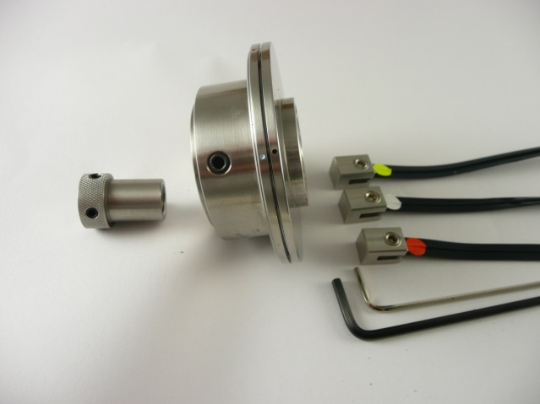
A film showing the installation of the
Tech-ni-Fold tool can be viewed on YouTube:
https://youtu.be/D2JToFQ14EA

Full Pack

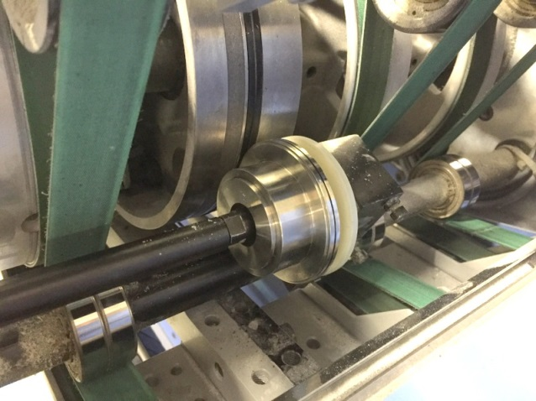

Release pressure of the existing scoring wheel away from the cylinder.

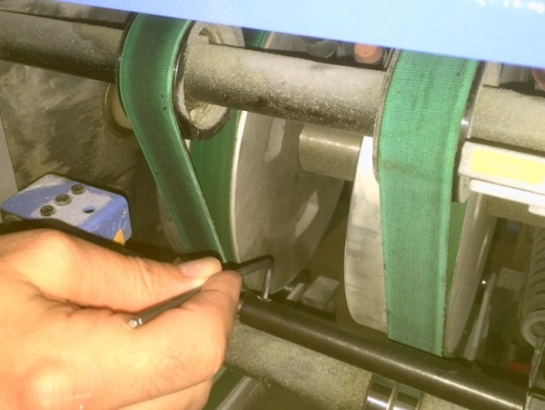
Loosen screw using hexagon key.

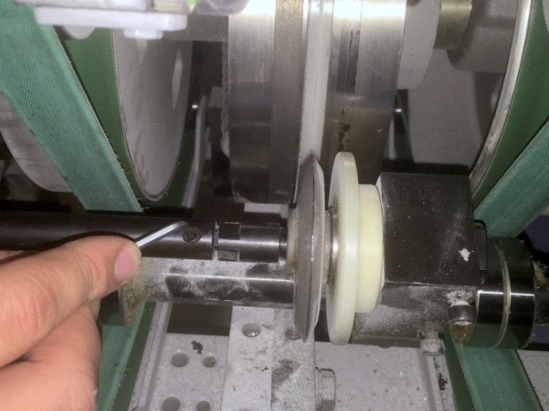

Loosen screw at opposite side of the bar by using the same hexagon key.

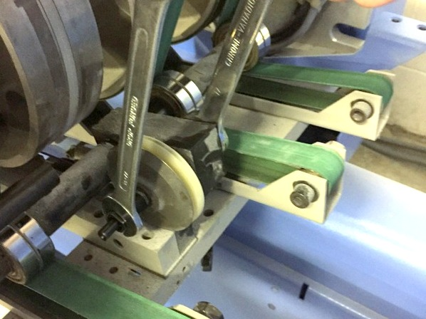
Remove the special shaped fixing nut using 13mm & 17mm spanners.

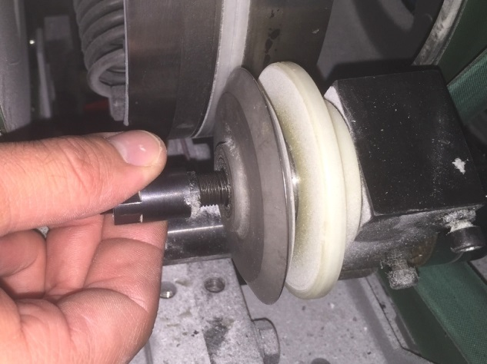
Unscrew the special shaped fixing nut.

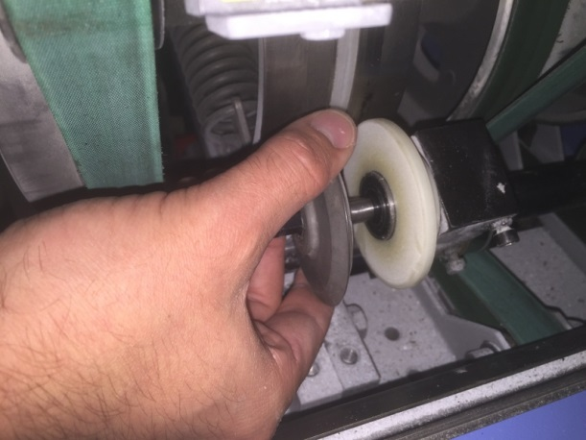

Pull off the metal scoring disc.

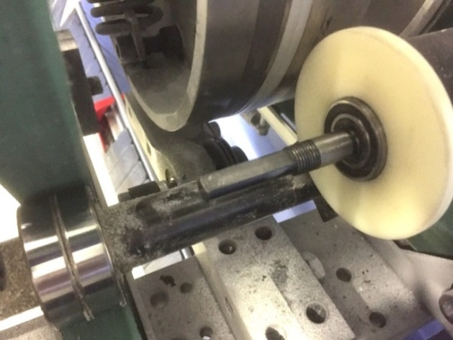

The cover feeder is now ready to rebuild using the Tech-ni-Fold tools.

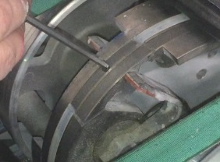

To remove the white plastic strip insert a hexagon key and turn anti-clockwise.

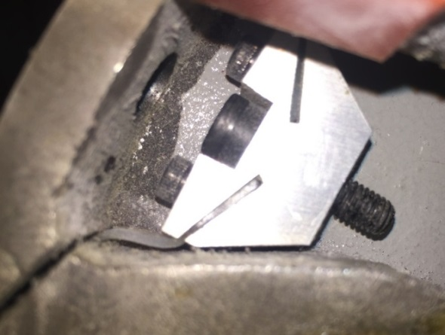

The white plastic strip holder will come lose from the cylinder drum.

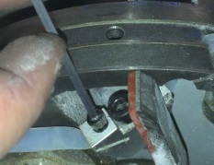
Remove the screw that holds the white plastic tape to the holder and remove from the drum. Clean off the adhesive from the channel in the cylinder drum.

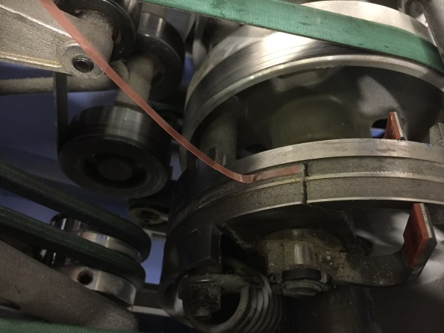
Apply the new red 2-sided adhesive tape.

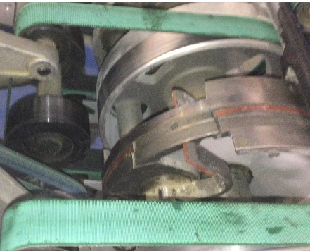

Do not cover the red tape over the cut out gap in the cylinder drum.

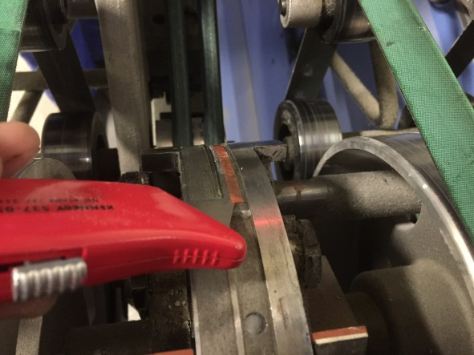

Using a sharp knife separate the red plastic tape from the adhesive strip.

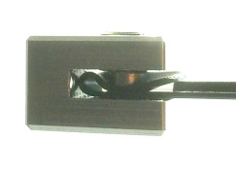
There are 3 metal matrix holders in each spine-creaser kit, these can be reused when the black rubber matrix is replaced.

Decide which coloured dot crease matrix to use.
1x Orange Creasing Matrix (M-171):
used to crease material between 100-135gsm
1x White Creasing Matrix (M-172):
used to crease material between 135-250gsm
1x Yellow Creasing Matrix: (M-173):
used to crease material between
250-350gsm
Insert the metal holder as shown. Gently stretch the black rubber matrix as it is placed in the channel around the cylinder drum.

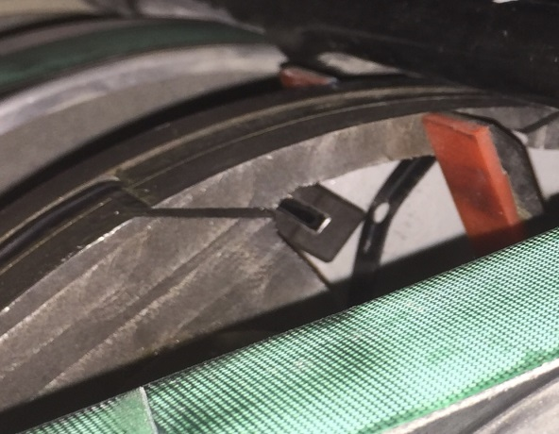

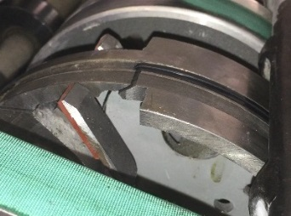

Push the remaining matrix through the slot.

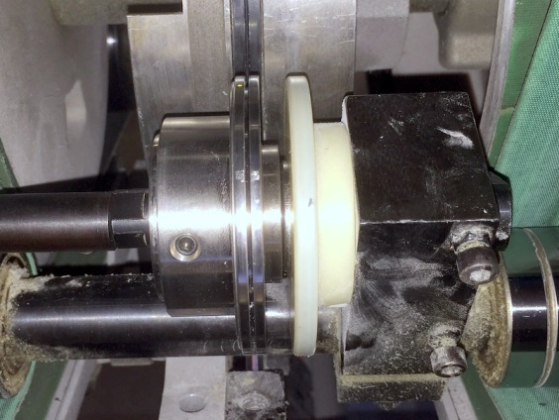

The width of crease on the female can be adjusted to suit any type of stock. This is done by simply loosening the fixing screw and turning the 2 outside metal discs apart. The 3 coloured dots can be aligned against the black dot to show which black rubber matrix is most suitable.
For example: yellow/black dot female = yellow dot creasing matrix (250-350gsm)

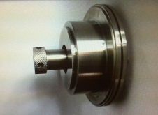
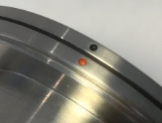

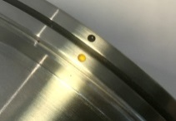
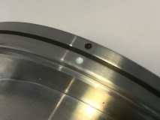

The special nut that secures the female into position is tightened against the bearing located inside the female. After this is done unscrew the nut ½ of a turn so that the female has approximately 1mm of side movement. The side movement is important as this allows the female to automatically centralise itself with the male creasing protrusion.
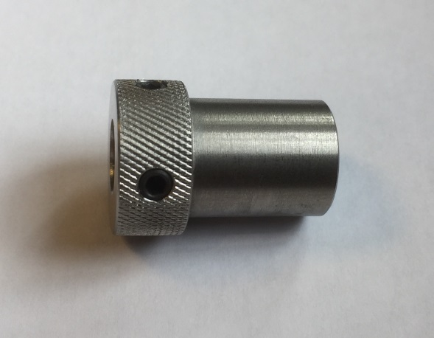

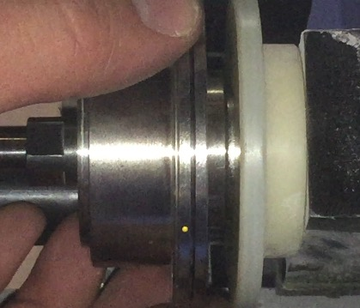
Secure the nut by tightening the 3 small screws using a 2mm hexagon key.

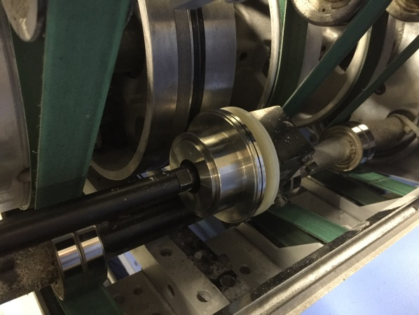
Slide the bar into position and tighten the 2 x 3mm hexagon screws.

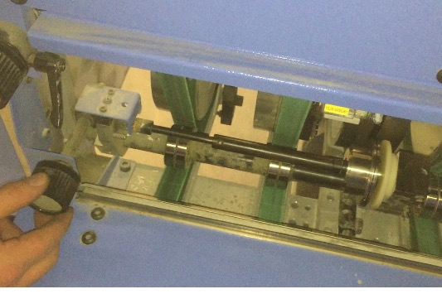
When a cover is fed between the female and the drum a medium pressure should stop the female from spinning easily. After the cover paper passes the female it should now spin freely.

Maintenance
It is possible to use the same red 2-sided adhesive tape for many matrix changes. However, when the black matrix no longer bonds to the cylinder drum the tape will require changing. To remove the old tape always use white spirit as this dissolves the adhesive glue. Dry off the drum with a clean cloth and then rub a piece of sand paper or equivalent scrubber over the clean surface to remove any remaining adhesive. If the drum is not fully cleaned of all residue white spirit then this will adversely affect the bond strength of the newly installed red tape. The black rubber matrix will fail to adhere properly to the machine drum and may fall off during operation.

